Multiple Regression

K1 Biaxal 1

C1 Biaxal 1

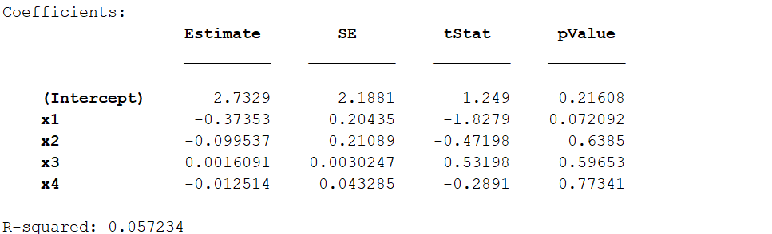

K2 Biaxal 1

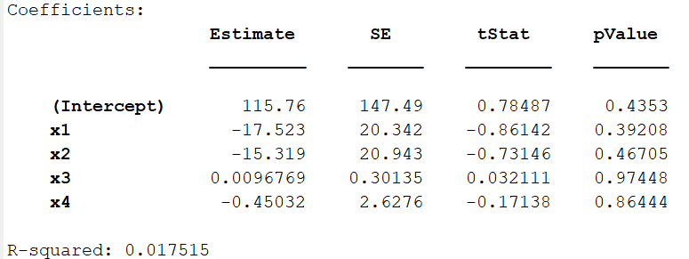

K1 Biaxal 2

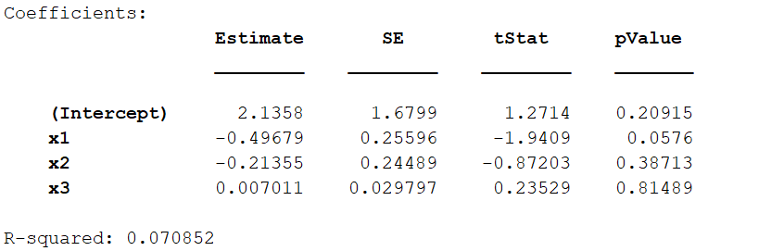

C1 Biaxal 2

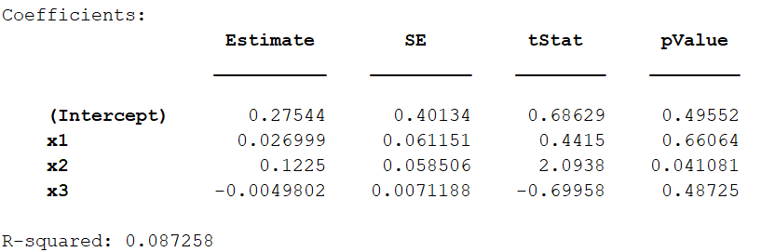

K2 Biaxal 2

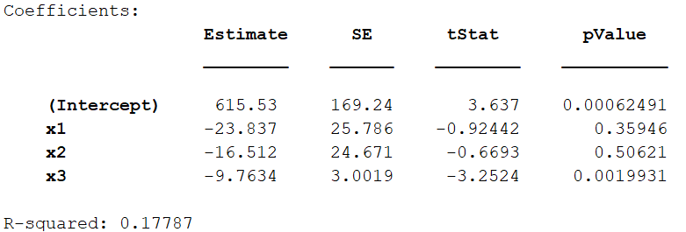

C1 Biaxial 1 Disp

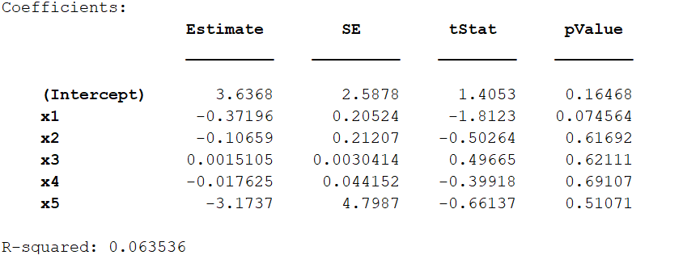

K1 Biaxial 1 Disp

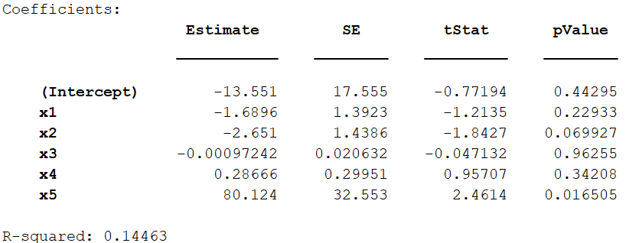

K2 Biaxial 1 Disp

